Python HW Link

High Level Overview

As Flight Simulators increasingly offer support for API interfaces (e.g. DCS, P3D), it now is feasible to move away from using Joystick interfaces (along with fun of dealing with USB issues) to a distributed system using Ethernet. Such as approach also simplifies output interfacing (e.g. indicators and gauges) as tasks and processes can be divided up across a number of devices and technologies.

This project builds on the Python/Raspberry Pi project used in the Huey Warning panel.

Table of Contents
High Level Overview 1
Definitions 3
Principles 3
Interfacing to the Sims. 4
P3d 4
DCS 6
X-Plane 6
Choice of platform for the hardware interface. 10
Program tasks 10
Protocols 10
Learning's from Different Modules 11
Determining which Simulator is Operational 11
Raspberry Pi 12
Initiating Scripts on Pi Nodes 12
Receive UDP Port utilisation 13
System Flows 16
Code Modules 18
Hornet Altimeter 18
PyHWLink_Arduino_Sender_Emulator 18
PyHWLink_Display_Output_Emulator 19
PyHWLink_GUI_Sender 19
PyHWLink_Lamp_Output_Emulator 22
PyHWLink_Keystroke_Sender 22
PyHWLink_Pri_Node_Input 23
pyHWLink_Radio_Control 23
pyHWLink_Serial 24
pyHWLink_USB_Reader 27
USB Interfaces 28
SimConnect_To_IP 30
PyHWLink_Control_XPlane 31
UDP_Input_Control 33
UDP_Reflector 34
Code Status 35
Coding Learnings 35
Logging 35
Command Line Parameters 36
Configuration Files 37
Error Handling In Python 38
Persisting Information 39
Networking in Python 40
Pick a Python Version 42
Processing Data 43
Working with Datasets 45
Working with Dictionaries of Dictionaries 45
Working with a GUI 46
PI Addressing 48
Interfacing to a GPS 48
Hardware Details 49
Graphical OLED – SSD1306 49
Code To Dos 51
pyHWLink_USB_Reader 51

Definitions

Primary Flight Simulator – the PC running an instance of the flight simulator
Primary Node – the Raspberry Pi node that communicates to the Primary Flight Simulator
Distributed Node – either a Raspberry Pi or Arduino (with Ethernet shield) that communicates to the Primary node.

Principles

- Use UDP for all communications where possible. This removes any possible performance issues associated with Nagle and TCP slow start. It also means components are loosely coupled, enabling them to be restarted without impacted other modules.
- Accept inputs from push, toggle, rotary, and rotary encoders.
- Outputs – analog and digital, text. All outputs are normalised before being send to output card/block. Should consider the format used by DCS-BIOS
- Multiple Sim support. As outputs are normalised the and loosely coupled now simulator support can be added without negatively impacting existing sim support. The receive interface from the Sim listens on unique ports, allowing the code to be running at all times.
- A shallow native shim is used to link the simulator to this hardware modules. As an example, LUA is used with DCS, for P3D Sim Connect used.
- Remote shutdown of all Pi nodes is provided through the master, once this has been invoked the nodes will shut down the OS, requiring either a hardware reset, and a power cycle to resume. Ideally outputs will display a checker board to reflect a shutdown command has been received.
- Indicator test, a single command will be supported to light all indicators, and perhaps cycle gauges.
- Downstream nodes should accept a request to report input switch position. On receipt of such a request the node will send a report of switch positions, probably at a rate of 20 per second. Need to consider reporting toggle switches in off position and three position switches.
- Will initially develop using DCS, and the variable names currently used by the A10
- The IP addressing of the ‘internal’ network (i.e. between the primary Flight Simulator computer) as well as between nodes will use the 172.16.1.X network. This enabled multiple flight simulators to share a common 192.168.X.X network. If there is only a single simulator the 172.16.1.X network can exist as a secondary address on the Primary network interface, if multiple Simulators share a network, then the internal network should use a different network interface on the Primary Computer.
- Mapping of physical inputs to simulator functions is performed on the Primary Pi node. This keeps the distributed nodes independent of flight sim, and relatively simple, enabling the use Arduino nodes as needed without adding unneeded complexity.
- Each distributed node will have a Unique identifier, which largely is used to uniquely identify different input modules.
- Each distributed node will maintain a state machine for its interfaces, sending only deltas to the Primary Node
- Distributed nodes receiving non-string values receive data as A=V:A1=V1:A2=V2
- Packets from input nodes will have the format of DX:A=V:A1=V1, where X is the input node number. The Node number is only indicated in the front of the packet, not at the individual AV pair.
- If an AV pair is not known it will be silently discarded unless the Primary node is in learning mode – where it will ask the operator what task should be assigned to the unknown AV pair.
- Learning Mode is determined by an argument on the command line ‘learning’ or in the
- Debug Mode is determined by an argument on the command line ‘debug’

Interfacing to the Sims.

P3d
Traditionally I’d worked with FSUIPC, work has provided a very consistent interface through the different generations of Microsoft’s, and now P3d sims. As SimConnect is now increasingly commonly used using that for the interface to the Sim.
This does mean at least part of the workload has to run on the PC. It is intended this will be a very shallow shim, with the bulk of the workload running on the Pi.
SimConnect is used to subscribe to a dataflow - which means that code must either be installed either on the PC running P3d or on a second PC with SimConnect installed and configured to point to primary PC.
As the code is light weight the plan is to run on Primary PC
Where necessary keystrokes will be used to send commands to the Sim (or using SimConnect)

Useful URLS
https://www.prepar3d.com/SDKv4/sdk/simconnect_api/managed_simconnect_projects.html
Variables
https://www.prepar3d.com/SDKv4/sdk/references/variables/simulation_variables.html
Code Fragments to Support SimConnect
// User-defined win32 event
const int WM_USER_SIMCONNECT = 0x0402;

// SimConnect object
SimConnect simconnect = null;

// this is how you declare a data structure so that
// simconnect knows how to fill it/read it.
// When Adding variables to receive need to add them to this datastructure as well as the request itself ininitDataRequest

[StructLayout(LayoutKind.Sequential, CharSet = CharSet.Ansi, Pack = 1)]
struct Struct1
{
// this is how you declare a fixed size string
[MarshalAs(UnmanagedType.ByValTStr, SizeConst = 256)]
public String title;
public double latitude;
public double longitude;
public double altitude;
public double airspeed;
public double elapsedsimtime;
public double zulu_time;
public Int32 time_zone_offset;
public double absolute_time;
public double plane_heading_degrees_true;
public double plane_heading_degrees_magnetic;
};
void simconnect_OnRecvSimobjectData(SimConnect sender, SIMCONNECT_RECV_SIMOBJECT_DATA data)
{

displayText("Received something don't know what to do with it but trying");

switch ((DATA_REQUESTS)data.dwRequestID)
{
case DATA_REQUESTS.REQUEST_1:
Struct1 s1 = (Struct1)data.dwData[0];

displayText("titles: " + s1.title);
displayText("Lat: " + s1.latitude);
displayText("Lon: " + s1.longitude);
displayText("Alt: " + s1.altitude);
displayText("Airspeed " + s1.airspeed);
displayText("Sim Time " + s1.elapsedsimtime);
displayText("Zulu Time " + s1.zulu_time);
displayText("Time Zone Offset " + s1.time_zone_offset);
displayText("Absolute Time " + s1.absolute_time);
displayText("Plane Heading True " + s1.plane_heading_degrees_true);
displayText("Plane Heading Mag " + s1.plane_heading_degrees_magnetic);

UDP_Playload = "latitude:" + s1.latitude;
UDP_Playload = UDP_Playload + ",longitude:" + s1.longitude.ToString();
UDP_Playload = UDP_Playload + ",altitude:" + s1.altitude.ToString();
UDP_Playload = UDP_Playload + ",airspeed:" + s1.airspeed.ToString();
UDP_Playload = UDP_Playload + ",zulutime:" + s1.zulu_time.ToString();
UDP_Playload = UDP_Playload + ",timezoneoffset:" +
s1.time_zone_offset.ToString();
UDP_Playload = UDP_Playload + ",trueheading:" +
s1.plane_heading_degrees_true.ToString();
UDP_Playload = UDP_Playload + ",magheading:" +
s1.plane_heading_degrees_magnetic.ToString();

span = DateTime.Now - TimeLastPacketSent;
mS = (int)span.TotalMilliseconds;
displayText("Its been this many mS since sending last packet: " +
mS.ToString());

if (mS >= 500)
{
Byte[] senddata = Encoding.ASCII.GetBytes(UDP_Playload);
udpClient.Send(senddata, senddata.Length);

TimeLastPacketSent = DateTime.Now;
}
break;

default:
displayText("Unknown request ID: " + data.dwRequestID);
break;
}

DCS

The type of interface used in DCS depends heavily on the aircraft being flown. The study models will use commands sent over UDP.

For the more generic models keystrokes will need to be send to the Sim. This means a shallow shim will need to run on the primary Sim. Current plan is to send Windows Keycodes over UDP, with the Windows API being used to inject keystrokes into the Keyboard buffer.

X-Plane

Originally tried to use the API interface that allowed reading and writing to variables, found the reading worked very well for subscribing to a data stream from the Simulator.
UDP Port | Use
49000 | X-Plane receives commands
49001 | X-Plane sends UDP payloads
49002 | X-Plane to iPad

Simply select the values of Interest, (eg Speeds, Lat,Long, Altitude) in the Telemetry screen.
A warning will be presented that the Network Data Output hasn't been configured. Enter IP Address and target port (as of 20181229 using common port 13136 - but this is likely to change)
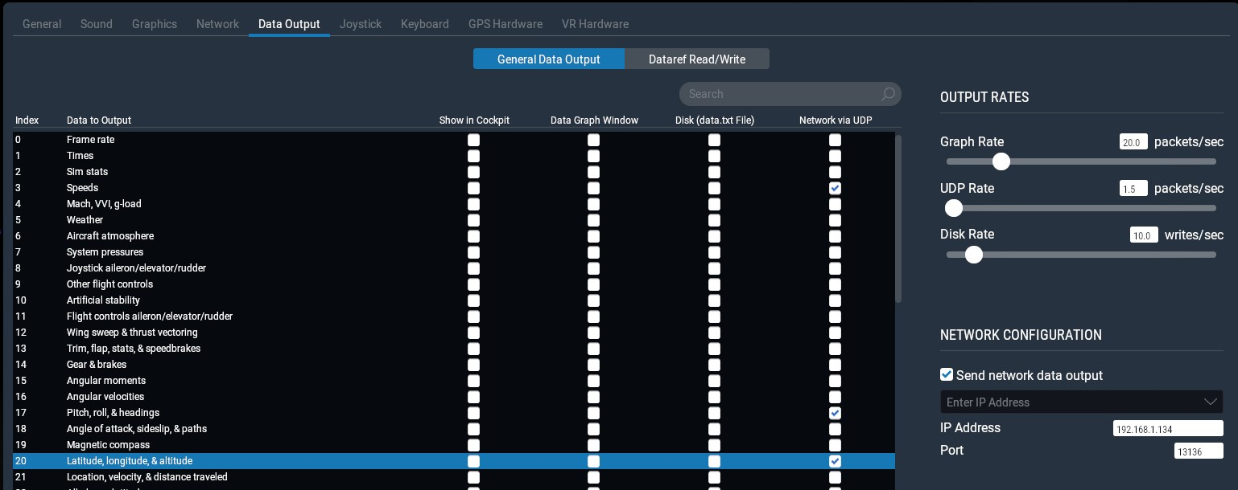Figure 1: X-Plane - Selecting Indexes to export
The following settings are used for driving the GPS
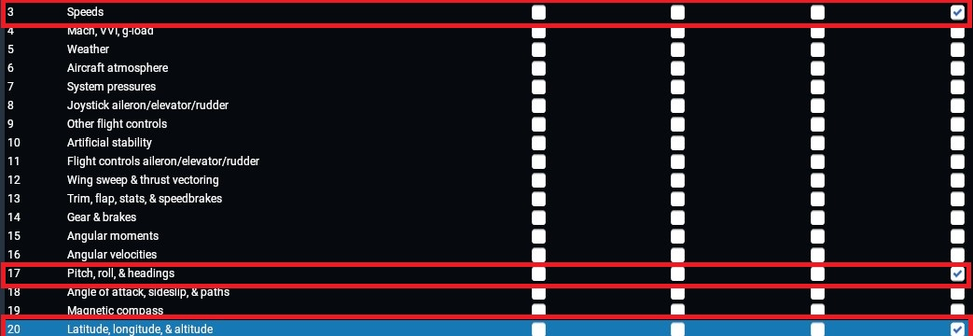Figure 2: X-Plane GPS Indexes selected
The mapping of values is described here https://www.x-plane.com/kb/data-set-output-table/

Selecting the three indexes results in there being three record sets sent per update (in a single packet). A very useful site that explains how this hangs together is http://www.nuclearprojects.com/xplane/receivedata.shtml.
Whilst it specifically discussed coding in c#, the packet format on the wire is the common.
All data is sent as bytes
- There are 41 bytes per sentence
  - The first 5 bytes are the message header, or "prologue"
    - First 4 of the 5 prologue bytes are the message type, like "DATA"
    - Fifth byte of prologue is an "internal-use" byte
  - The next 36 bytes are the message
    - First 4 bytes of message indicates the index number of a data element, as shown in the Data Output screen in X-Plane
    - Last 32 bytes is the data, up to 8 single-precision floating point numbers (4 bytes per floating point number)

Using that API that was used for reading values don’t work so nicely in the opposite direction. This was resolved relatively simply, over googling around, found the needed information was sitting with the X-Plane installation itself.
D:\Xplane11\X-Plane 11\Instructions\X-Plane SPECS from Austin\Exchanging Data with X-Plane.rtfd

Some important Tips from this guide
NOTE: X-Plane always receives on port 49000.
NOTE: Any strings that you send should be null-terminated!

To send a UDP message to X-Plane:
-the 4-letter label
-a byte of value ‘0’
-the message data you want to send

RUN A COMMAND: CMND
DATA INPUT STRUCTURE is a string

CMND0+sim/flight_controls/flaps_up

The data part of this message is simply the command that you want X-Plane to initiate!

To see available X-Plane commands, run X-Plane and go to the Settings menu, Keyboard tab or the Joystick Tab.
The commands are the group name you see in the centre of the screen, PLUS command string in the right side, all run together.
Commands can be seen by hovering over the desired action
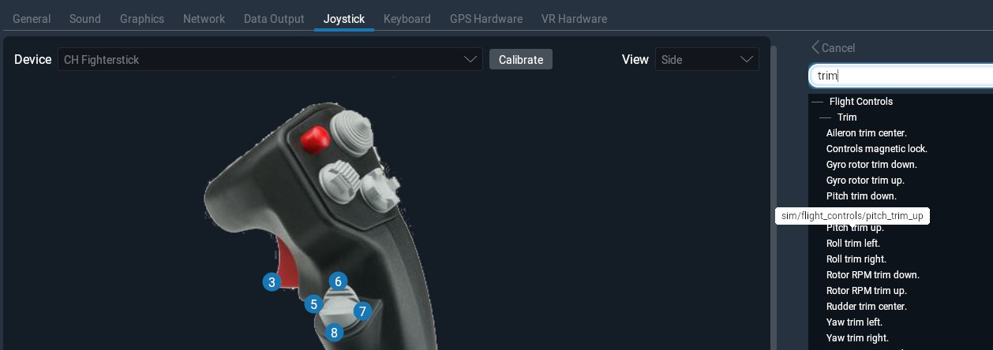Figure 3: X-Plane Joystick showing commands

Or via the keyboard

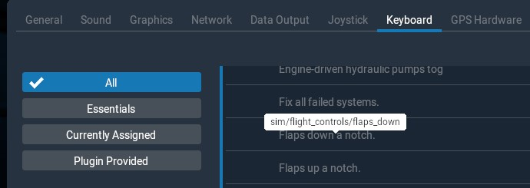Figure 4: X-Plane Keyboard showing commands

To set values in X-Plane you can explicitly write to a DREF, this blog provides a very useful guide - https://blog.shahada.abubakar.net/post/linux-udp-network-client-library-for-x-plane-10-and-11?
BECN - Beacon broadcast. There is no equivalent feature for this in ExtPlane. Every running instance of X-Plane will broadcast it's IP address and command port number on your LAN in a BECN message, every second. With this, it is possible for devices on your LAN to "auto-discover" the IP and port number of the X-Plane server. It is also possible to auto-detect if there are multiple X-Plane servers running on your LAN, and offer the user a choice of which one they wish the device to connect to. It's a lot better than having the user manually configure the device with the IP and port number of the server, and helps a lot when you have more than one X-Plane PC. Note that this is a multicast datagram, so you will need to "subscribe" to the multicast address 239.255.1.1 port 49707.
RREF - Request subscription to a DataRef. The client sends this message to X-Plane's command port, together with a frequency (in Hz) and an identifying number. X-Plane will then automatically send the client a response RREF message at the frequency specified containing the current value of that DataRef . To unsubscribe, you send the RREF again with a frequency of 0.

DREF - Set the value of a DataRef. You send a DREF together with the value you want, and the name of the dataref.

CMND - Gets X-Plane to execute a command. You send a CMND together with the name of the Command you want invoked, and X-Plane executes it.

Choice of platform for the hardware interface.

Whilst the Raspberry Pi offers the nicest development and troubleshooting environment, it lacks the high pincount found on an Arduino. The Arduino will require an Ethernet shield (and not all Ethernet shields are created equal, have run into issues with an IOT shield that had a poorly cooled chip which caused lock ups).

As the Arduino codes runs without an intermediate operating system, it offers the highest performance for IO related tasks such as driving stepper motors.

Have ran into issues with lockups in the 737 overhead display, possibly due to incorrectly terminated strings or invalid characters included in string. Strongly bounds checking will be performed on the Pi before strings are send to Arduino displays.

As we are not bound by the 128 input limit associated with either windows DirectX or the 32 input limit associated with FSUIPC, OverPro’s Arduino Joystick interface can be used with 256 inputs reducing the number of controllers needed for the pit. Hopefully a single controller for Port, Starboard and Forward zones can be used. OverPro’s code will be modified removing the USB interface, instead storing switch state and reporting deltas after completing a full scan of 256 inputs. Unsure if rotaries will be supported, no logical reason why not.

Program tasks

The workload is divided into two programs – one dealing with inputs, the other with outputs. Both are fundamentally loops which briefly block awaiting receipt of a UDP packet either from the simulator/shim or from the input devices.

Command line parameters are used to get a debugging level as well as enable a configuration mode.

Configurations will be held in two separate files, the format of these files is yet to be determined, but JSON is mostly likely. The configuration files include:
- IP Address code listens on (optional - if not explicitly configured 127.0.0.1)
- Port Code listens on (optional – if not explicitly configured 7784 for input module and 7785 for output module. (still considering whether to leave export.lua sending direct to existing Arduino units)
- Mapping of input to aircraft commands and aircraft outputs to physical displays/gauges.

Protocols

Where possibly output values will be carried directly mapping to value to be displayed, and may be integer, float, or string. Indicators/Solenoids will be represented as a 0 or 1.

Data will be carried as AV pairs A1:V2, A2:V2. The data packet will be preceded with a D.

Operational tasks such as shutdown, reboot, refresh switch state will be preceded with a C (command), and a single operational task. e.g. C9999.

Operational Task

Task Id | Task
CQ | Send all switch states

Ikarus uses the following format

# If Sending Commands to DCS with Ikarus installed
# The values to be sent can be found
# C:\Program Files\Eagle Dynamics\DCS World\Mods\aircraft\Uh-1H\Input\UH-1H\joystick
# Structure is
# C - Command
# 15 - Cockpit Device Id
# 3003 - Unknown but seen in multiple places
# Switch Position
# Send to Port UDP_PORT = 26027
# MESSAGE = "C15,3003,-1" - Turns Test Switch on - All warning lights
# MESSAGE = "C15,3003,0" - Turns Test Switch to centre
# MESSAGE = "C15,3003,1" - Turns Test Switch to Reset - clears caution on front panel
# Bright/Dim 15,3004

Learning's from Different Modules

Determining which Simulator is Operational

Ideally the number of changes made to ‘downstream’ modules should be minimised. As X-Plane packets always originate from 49001, this can help distinguish which Sim is running. The following approach was used in the GPS code.

# Need to decode the payload to convert from bytes object to a string
# Don't do this is the packet is from XPlane Sourced from 49001
if (Source_Port != 49001):
# SimConnect P3d
SendingSim = 'SimConnect'
ReceivedPacket = data.decode()
ReceivedPacket = str(ReceivedPacket)
else:
SendingSim = 'XPlane'
ReceivedPacket = data

Raspberry Pi
The USB.Core library provides a low level interface for the Raspberry Pi. It is able to scan the USB bus and report back what is attached.
The code scans the USB bus looking for a specific device, and then detaches the device from the Kernel driver. Once this is completes it then runs a set configuration, and then asks for a data block from the target device on a frequent interval.
A quick check is made to see if the value returned is different from the last interval, if it is then the list holding switch positions if refreshed

Maintaining the Pi

pi@GenFrontPi:~ $ sudo apt-get upgrade
Reading package lists... Done
Building dependency tree
Reading state information... Done
Calculating upgrade... Done
0 upgraded, 0 newly installed, 0 to remove and 0 not upgraded.
pi@GenFrontPi:~ $ sudo apt-get dist-upgrade
Reading package lists... Done
Building dependency tree
Reading state information... Done
Calculating upgrade... Done
0 upgraded, 0 newly installed, 0 to remove and 0 not upgraded.
pi@GenFrontPi:~ $

Initiating Scripts on Pi Nodes

Instead of trying to start python directly from crontab, use shell script (usually my_server) to
start things

To get the script to autostart
sudo crontab -e

And add line
@reboot sh /home/pi/Documents/Flightsim/Huey\ Caution\ Panel/my_server 2>&1

Which results in the crontab file looking like

# Edit this file to introduce tasks to be run by cron.
..
..
#
@reboot sh /home/pi/Documents/Flightsim/Huey\ Caution\ Panel/my_server 2>&1

Originally a separate shutdown script was operated, need to work out why it was commented out, possibly as the script below only ever reaches remoteshut.py after the receiver code exits, which is never…

### BEGIN INIT INFO
# Provides: my_server
# Required-Start: $remote_fs $syslog $network
# Required-Stop: $remote_fs $syslog $network
# Default-Start: 2 3 4 5
# Default-Stop: 0 1 6
# Short-Description: Simple Web Server
# Description: Simple Web Server
### END INIT INFO

#! /bin/sh
# /etc/init.d/my_server

export HOME
echo "Starting My Server"
cd /home/pi/Documents/Flightsim/Huey\ Caution\ Panel
sudo /usr/bin/python receiver_004.py 2>&1 &
#sudo /usr/bin/python remoteshut.py 2>&1 &
exit 0

Receive UDP Port utilisation

A number of these values are referenced from soic_conv_ExportStart.lua from DCS

Port | IP Address | Description
 | 127.0.0.1 | New DCS Emulator
7777 | 127.0.0.1 | SOIC on Primary Sim PC
7784 |  | Input Codes listens on
7788 | 127.0.0.1 | Arduino Sender Emulator. Sends to Pri_Node_Input
7788 | 127.0.0.1 | Arduino Sensor. Sends to Pri_Node_Input
7789 | 127.0.0.1 | GUI_Sender. Sends packets to Pri_Node_Input
7790 | PC Running Sim | Keystroke_Sender
7791 | 127.0.0.1 | Lamp_Output_Emulator
7792 | 127.0.0.1 | Display_Output_Emulator
7793 | 127.0.0.1 | XPlane_Decode
7794 | 127.0.0.1 | Radio_Control
7795 | 127.0.0.1 | USB_Reader
13135 | 192.168.1.105 | Fuel Hands on A10
13135 | 192.168.1.106 | Fuel Display (OLED on A10)
13135 | 192.168.1.107 | Compass and Clock Analog hands
13135 | 192.168.1.108 | Clock Digits
13135 | 192.168.1.109 | General Stepper
26027 | 127.0.0.1 | Pri_Node_Input
27000 | 127.0.0.1 | UDP_Reflector
49000 | 127.0.0.1 | X-Plane UDP listener

IP Addressing – Backend 172.16.1.X

Backend
172.16.1.2 | Primary Pi
Input Devices
172.16.1.10 | Left Aurduino
172.16.1.11 | Front Arduino – Device id 1 | 0xA9,0xE7,0x3E,0xCA,0x35,0x02  A9:E7:3E:CA:35:02
172.16.1.12 | Right Arduino – Device id 2 | 0xA9,0xE7,0x3E,0xCA,0x35,0x04  A9:E7:3E:CA:35:04. Had real weirdo where traffic would pass through home switch and wireless – used {0x00,0xD0,0x3E,0xCA,0x35,0x04} to resolve
Output
172.16.1.21 | Front Led Arduino | 0xA9,0xE7,0x3E,0xCA,0x35,0x03  A9:E7:3E:CA:35:03

Adding RS232 Interface

Ref - https://www.instructables.com/id/Read-and-write-from-serial-port-with-Raspberry-Pi/

Using Max 3232 based interface which supports 3.3 to 5V
Pin Used (remembering pin numbers does include both sides of header – so these pins are adjacent.
4 (5V),
6 (GND)
8 (TX),
10 (RX)

Can use sudo raspi-config → Interfacing Options → Serial to enable/disable console through serial interface. In the disti used in Dec 2018 it is disabled by default – enabled to validate the TX led flashes during the reload process.

Notes from the Huey readme

Git Commands

Clone Repo
git clone https://github.com/bnepethomas/bne-arduino-flight-simulator-interfaces.git

git config --global user.email "your email”
git config user.name "your name"

Watch for untracked files

$ git add .
$ git commit .
$ git push

System Flows
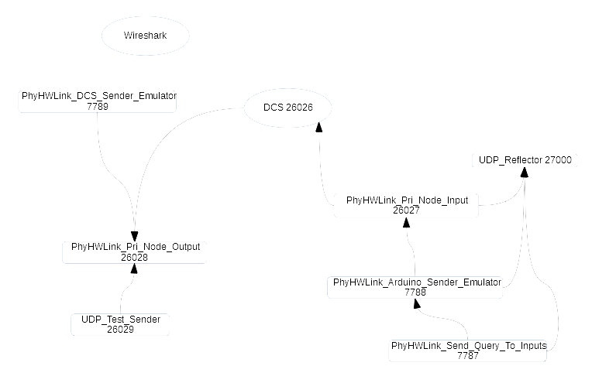Figure 5: System Flows
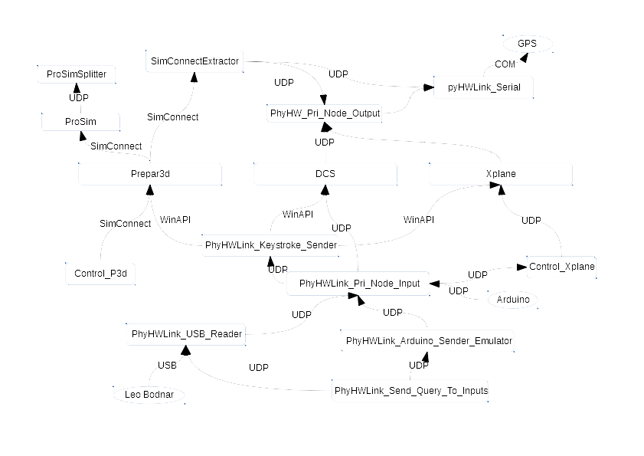Figure 6: Detailed System Flows

Code Modules

Hornet Altimeter

The Altimeter project is broken into two pieces – the code to drive the needle, and the code to drive the OLED. Originally the code was all run on an Arduino, but largely due to my lack of skills in dealing with an environment that needs to be interrupt driven, the workload is split between an Arduino for driving the motor, and a Raspberry Pi for the OLED code.

Altimeter OLED

The Altimeter OLED displays the Altitude (ten thousands, thousands, hundreds) and the pressure setting (QNH). The last two digits will either not be displayed
The Altimeter OLED code is based on sample code from Adafruit. Hardware interfacing details are found later in this document.

‘Rolling’ characters are used, which do increase the workload but considerably improve the realism of the altimeter. The minor digits (ones and tens) are now updated, they are left as ‘0’s which may either be engraved in the faceplate or just simply rendered as ‘0’s. The major digits (ten thousands, thousands, and hundreds) are updated and do roll.

There are two special use cases, the left hand hash, which sits in the ten thousands column, and the value at which digits roll. The digits should hold a centered position until they are close to changing value, and only then do then do they roll. The roll is done within the last 100 feet. As the hash is different height to characters it as its own position value (hatch_top). It is located on the ten thousands column.

Drawing the hash. Whilst an option was considered to use a predrawn graphic for the hatch, it ultimately was not a large coding effort to draw the hatch. This is done by drawing a white box and then drawing a series of black lines

PIL is used for the graphical elements.

Characters are drawn using column spacing, with a spacing currently of 23 pixels. Pixels are used to locate elements on the canvas. On the X co-ordinates numbers increase from left to right. Row positions are a little more interesting, with negative values used for the top most rows.

PyHWLink_Arduino_Sender_Emulator

Emulates a Arduino running OverPro’s Joystick interface with an Ethernet shield.
As we aren't exposed to an any Joystick button limits, there are 256 buttons supported
Instead of using the stub to provide a Joystick via USB, delta are sent to a process running on a Raspberry Pi which maps these deltas to commands for the Sim

The Arduino code is independent of the aircraft and simulator that is running, which simplifies its operation.

There is a receive operation where the Arduino will report the state of all
256 inputs. This will be spread across several packets with a 300mS delay between
# the packets. The trigger packet is a simple 'CQ'

It is configurable, with the Input_Module_Number, which determines which input module it is emulating, the max packet size (basically to throttle the number of entries in a single packet), which hopefully throttles the number of entries concurrently hitting the downstream modules.

The likelihood of change determines the rate of change of ‘input’ values in a given cycle.

Sends to | Port
PyHWLink_Pri_Node_Input | 26027
UDP_Reflect | 27000

Listens to | Port
PyHWLink_Send_Query_To_Inputs | 26027

The Packet format is a D followed by Module_Number, Switch_No, Current_Switch_State

The packet payload is not fixed length -
D00:003:0,00:005:0,00:006:1,00:007:1,00:009:1

PyHWLink_Display_Output_Emulator

This module receives UDP packets containing desire output state for displays such as OLED or 7 Segment Led..

Listens to | Port
PyHWLink_Pri_Node_Output | 7792

b'D,1:0,2:1,3:1,4:1,5:0,6:0,7:0,8:0,9:1,10:1,11:

PyHWLink_GUI_Sender

As the name suggests this module was developed to provide a GUI to send simulated button/switch transitions to Pri_Node_Input. It uses the tkinter library that provides platform support for MacOS, Windows and the Raspberry Pi. Only MacOs required an install of the tkinter environment.

There are two types of button actions provided:
1: Classic Toggle Switch Action where switch position is held, and
2: A Push button, where a simulated Push and Release action is transmitted with a relatively short delay. Its is up to Pri_Node_Input to determine if it will act only on the Press or on both Press and Release (as may be needed if Key Strokes are being sent)

The same packet format is used as the Arduino_Sender_Emulator
b'D01:005:1'

The user can select which module is being emulated (1-5)

Sends to | Port
PyHWLink_Pri_Node_Input | 26027
UDP_Reflect | 27000

The GUI is manually laid out.

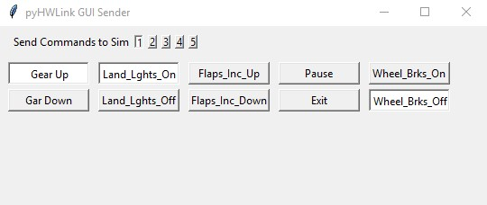Figure 7: PhyHWLink_GUI_Sender GUI

Switch  No | Role | Pressed | Released | Temp or Held
1 | Gear | Gear Down | Gear Up | Held
2 | Landing Lights | Lights On | Lights off | Held
3 | Flaps Increment Up | Flaps Inc Up |  | Temp
4 | Pause Sim | Pause Sim |  | Temp
5 | Exit Sim | Exit Sim |  | Temp
6 | Wheel Brakes | Brakes On | Brakes Off
7 | Flaps Increment Down | Flaps Inc Down
8
9
10
11
12
13
14
15
16
17
18
19
20
21
22
23
24
25
26
27
28
29
30
31
32
33
34
35

PyHWLink_Lamp_Output_Emulator

This module receives UDP packets containing desire output state for lamps. It may be extended to receive string information for airspeed, radios etc, but initially just aimed at displaying output state.

Listens to | Port
PyHWLink_Pri_Node_Output | 7791

This only has two fields as it emulates a single end point. The same packet format is used as the Display_Output_Emulator
D,1:0,2:1,3:1,4:1,5:0,6:0,7:0,8:0,9:1,10:1

PyHWLink_Keystroke_Sender

This module receives characters to be send to whatever application has focus, which should ultimately be the flight sim. It uses a low level API to increase the likelihood interoperability with DirectX based games.

Sends to | Port
Whatever Application currently has focus | Windows API for local machine

Listens to | Port
PyHWLink_Pri_Node_Inputs (and derivatives) | 7790

PyHWLink_Pri_Node_Input

This module is the workhorse of the simulator infrastructure. It receives AV pairs from input devices/process over UDP, translating them into either commands that are send direct to the Sim, or are send to Control_Via_Keyboard, which as the name suggests injects keystrokes into the Simulator using the Windows API.

It has a learning mode which, as the name suggests, listens to events, and enables the user to assign a task to an event. Events are stored in ‘input_assignments.json’

Pri_Node_Input is reflector enabled, which means it sends a copy of its outputs to the UDP_Reflector process for forwarding to WireShark as needed.

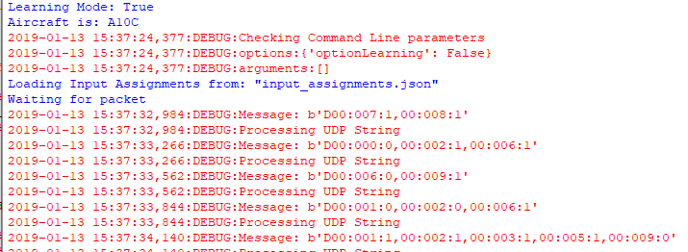Figure 8: PhyHWLink_Pri_Node_Input User Interface

pyHWLink_Radio_Control

This module listens to state updates from USB_Reader. It is currently in a experimental stage with the following goals:
- Locally Store State (such as current radio frequency) and either directly or incremental update Sim state. Ideally direct updates will occur, which should be possible with P3d, but unsure if DCS allows direct setting of radios, or if button commands will be needed to increment radio channels
- Enable different roles to be assigned to a single rotary encoder based on whether the encoder is pressed or not
- Determine how to ‘accelerate’ updates of a rotary encoder. This is largely for roles where precision is required, but a large number of values must be moved through, such as heading and airspeed settings on the autopilot panel.

Sends to | Port
TBA

Listens to | Port
PyHWLink_USB_Reader | 7794

pyHWLink_Serial

This module is probably better called pyHWLink_GPS, initially named to develop a Rasperberry Pi serial stack. The single modules supports DCS, P3d and X-Plane simultaneously. In part this is due to a common on the wire format used for P3D (as information comes via a SimConnect shim).
X-Plane is a little different over the wire as data is packed using a binary format.

Sends to | Port
Serial Port on Pi

Listens to | Port
DCS, XPlane, and lightweight SimConnect Shim | 13136

DCS Interfacing Code

As DCS is a API/Script Native, there was little extra to do to export information to drive GPS. The same target port and X-Plane was used (13136)

The initialisation code largely is involved with configuring the socket to use.
Text 1: DCS LUA Initialisation - Code Export.lua

package.path = package.path..";.\\LuaSocket\\?.lua"
package.cpath = package.cpath..";.\\LuaSocket\\?.dll"

socket = require("socket")

gps_export_port = 13136
gps_export_host = "192.168.1.135"
gps_export_socket = require("socket")
gps_export_con = socket.try(gps_export_socket.udp())
gps_export_socket.try(gps_export_con:settimeout(.001))
gps_export_socket.try(gps_export_con:setpeername(gps_export_host,gps_export_port))
The Event code clears a table and progressively add entries to the table. Once the 5 rows are populated, they are assembled and send out the socket. The event is then rescheduled to fire again in 500mS.

Text 2: DCA LUA Event Code - Export.lua

function LuaExportActivityNextEvent(t)

local tNext = t
local gps_export_flightData = {}

table.insert(gps_export_flightData,"latitude:"..LoGetSelfData().LatLongAlt.Lat) -- LATITUDE

table.insert(gps_export_flightData,"longitude:"..LoGetSelfData().LatLongAlt.Long) -- LONGITUDE

table.insert(gps_export_flightData,"altitude:"..LoGetAltitudeAboveSeaLevel()) -- ALTITUDE SEA LEVEL(MTS TO FT)

table.insert(gps_export_flightData,"airspeed:"..LoGetTrueAirSpeed() * 1.94) -- TRUE AIRSPEED (M/S TO KNOTS)

table.insert(gps_export_flightData,"magheading:"..LoGetSelfData().Heading * 57.3) -- HEADING (RAD TO DEG)

gps_export_packet = gps_export_flightData[1] .. "," ..
gps_export_flightData[2] .. "," .. gps_export_flightData[3] .. ","
gps_export_packet = gps_export_packet .. gps_export_flightData[4] .. "," ..
gps_export_flightData[5]

gps_export_socket.try(gps_export_con:send(gps_export_packet))

tNext = tNext + 0.5 --repeat every 1/2 second
return tNext
end

The packet format uses ‘,’ separators which ‘:’ as a demarcation for attribute name and values.
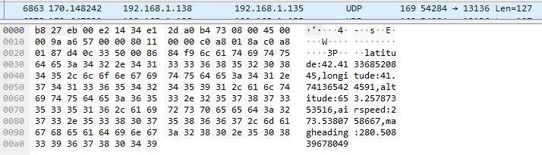

X-Plane
The name data output is packed binary. Once the needed values are selected for output, X-Plane exports them in a packed format.

Figure 9: Fields Selected for GPS Output
As the data is encoded in a binary format , it looks a little hostile on the wire.
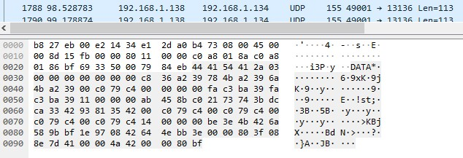Figure 10: X-Plane GPS Data on the wire
As discussed earlier in this document, for every field selected, a separate UDP packet will be sent. Each Index ‘flow’ is able to be identified by the 6th byte in the payload.

pyHWLink_USB_Reader

This module interfaces directly to USB hardware. It runs a loop looking for any deltas in button positions. If a delta is detected, only the changed button sates are sent to Pri_Node_Input.

It also listens out for a request from Send_Query_To_Inputs, on receipt of such a request, all button state is send to Pri_Node_Input. Button state delivery is staggered in 20mS intervals to reduce the likelihood of over whelming the target simulator. Both open and closed button state is sent.

Sends to | Port
PyHWLink_Pri_Node_Inputs | 26027
UDP_Reflector | 27000

Listens to | Port
Send_Query_To_Inputs

USB Interfaces

There still is a need to use USB interfaces, such as for a High Resolution Analog interface (which already has noise reduction built in) or for Rotary Encoders. As the Leo Bodnar cards provide a solid rotary interface they will be used for inputs on radios and autopilots.

The follow vendor and product Ids are used for the Leo Bodnar cards:

 | Vendor Id | Product Id
BU0836 | 0x16c0 | 0x05b5
BU0836X | 0x1dd2 | 0x1001
BBI-32 | 0x1dd2 | 0x1150

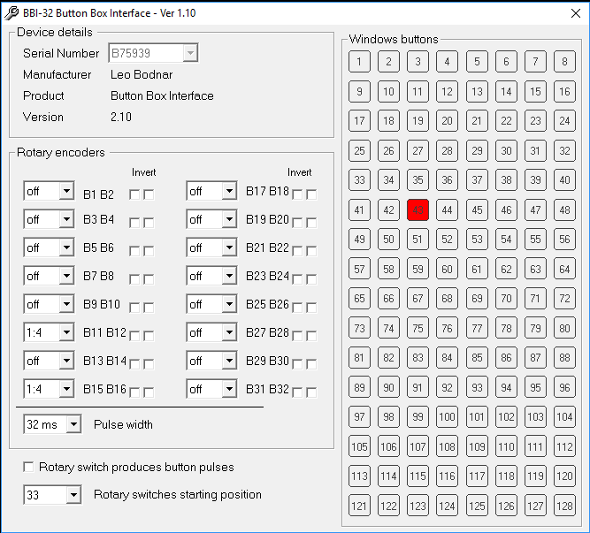
The BBI-32 supports a special adapter for rotary switches that uses only two pins to monitor 12 inputs. This considerable reduces the amount of cabling needed to track rotary switch inputs. Up to 11 of these can be used on a single BBI-32, and they must be connected to the first 11 inputs. The BBI-32 configuration software enables you to determine at what port number the additional ports will start appearing

Rotary encoders can be connected to any two sequential inputs. The BBI-32 rotary encoder configuration defaults to 80mS which means the minimum time between pulses is 80mS. Need to decrease to get a faster response time.

Needed to change the Rotary encoder from 1:1 to 1:4 to stop immediate echo as well as increase Pulse width to 32mS

The USB interfaces will still be normalised over the UDP interfaces, and should support requests to report the status of all Joystick interfaces, perhaps with a 10mS delay between the sending the status of each button input.

It appears that different Operating Systems provide different levels of accessibility, especially around devices they are Human Interfaces (HIDs). The Mac won’t let you easily attach to the HID. This isn’t too much of an issue, but does mean testing needs to be done on the Pi itself.

SimConnect_To_IP

Currently SimConnect_To_IP is functional but can do with a clean up, and probably a rename. It currently sits outside the folder where the bulk of the python code exits. The folder is ‘bne-arduino-flight-simulator-interfaces\SimConnectExtractor’. The project is called SimConnect_to_IP.sln

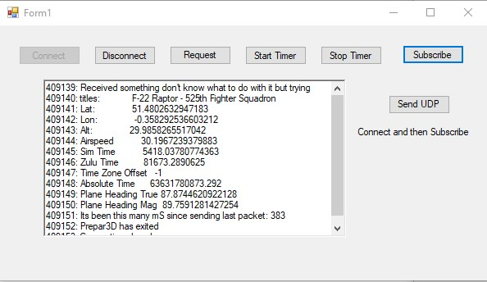Figure 11: SimConnect_To_IP GUI

As of Jan 28 2019 there a number of buttons that aren’t needed. All that is needed to operate the code is to select connect, and then subscribe. As the button suggests, SimConnect_To_IP will then subscribe to a data stream from P3d. This is more efficient that polling P3d, as you are setting up structures and allowing P3d to update on a time base it expects.

Sends to | Port
pyHWLink_Serial | 13136

Listens to | Port
P3d SimConnect | SimConnect API

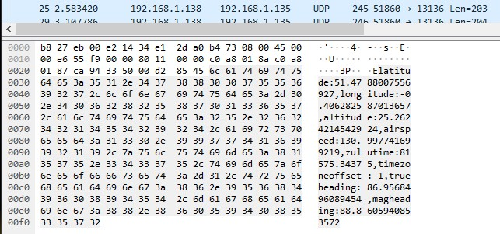Figure 12: SimConnect_To_IP Data on the wire

PyHWLink_Control_XPlane

Whilst extracting information from X-Plane was relatively straight forward, trying to control X-Plane was a little more exciting.

Was originally trying to use the ‘inverse’ of data extraction by writing to an offset with a set of parameters.

('DATA'.encode('utf-8'), 0, 14, 0, -999, -999, -999, -999, -999, -999, -999)

This didn’t work so well. However found some very useful information at

http://blog.shahada.abubakar.net/post/linux-udp-network-client-library-for-x-plane-10-and-11, specifically in the section

CMND (Client to X-Plane)

- char [5] name = CMND\0
- char[] cmnd = "sim/flight_controls/flaps_down"

This references a document in the X=Plane folder which explains how to control X-Plane,for X-Plane 11.26, it is found in X-Plane → Instructions → X-Plane SPECS from Austin → Exchanging Data with X-Plane.

The commands that are available to sent can be found :
To see the (plethora) of X-Plane commands, run X-Plane and go to the Settings menu, Joystick and Equipment screen, Buttons:Advanced tab.
The commands are the group name you see in the center of the screen, PLUS command string in the right side, all run together.
This didn’t seem to be there in 11.26, but if you go Keyboard → All and then over over something if interest, you see the required string.

Once you have the needed string it needs to be assembled, packed and sent. The payload header is CMD, followed by a 0 (need to work out what that is), and then the string to be send.

values = ('CMND'.encode('utf-8'), 0, 'sim/flight_controls/flaps_down'.encode('utf-8'))
packer = struct.Struct('4s B 32s')
packed_data = packer.pack(*values)
sock = socket.socket(socket.AF_INET, socket.SOCK_DGRAM) # UDP
sock.sendto((packed_data), (UDP_IP_Address, UDP_Port))

During initial testing – not all values operated. Inc-Flaps-Up, Inc-Flaps-Down. Wheels-Brakes-On appeared to operate at start of flight, not not after flight. Sim Pause and Quit operated ok, Gear-Up, Gear Down, Landing Lights didn’t operate. This was due a slightly lazy copy of the initial config which has a fixed length for the string.

After correcting that – landing lights and brakes not operating correctly. Changed from brakes_maximum to brakes_regular (which mapped to keystroke B)

Lights was due to another copy and paste mistake, second part of string was flight controls when it should have been lights.

sim/flight_controls/landing_lights_on
sim/lights/landing_lights_on

Assigned a keystroke to the hold brakes regular, what this seems to do is require keystroke to be held, so for the moment will avoid hold commands.

Sends to | Port
X-Plane | 49000
UDP_Reflect | 27000

Listens to | Port
PyHWLink_Pri_Node_Inputs | TBA

UDP_Input_Control

Based on OverPro’s Joystick controller, this reads a matrix of switches and sends changes over UDP. As this is running on a Arduino Mega – it is not coded in Python. Currently it is used just for digital inputs, but could be extended to also monitor analog axis, sending deltas as the input move, just need to consider what ‘smoothing’ algorithm could be used.

Sends to | Port
PyHWLink_Pri_Node_Inputs | 26027
UDP_Reflector | 27000

Listens to | Port
Send_Query_To_Inputs | 7788

OverPro’s original code supported 256 buttons, in a 16 * 16 Matrix on a Arduino Mega (2560 R3), but due to the Ethernet Shield pulling Columns 13 and 14 to 1.5V at all times the Matrix is 16 * 14. As of 21/4/2019 had issues with Column 12 (counting from 0 – which may explain 13 above) and above not reporting changes. Column 12 cases Arduino to crash)

Digital Pins 22- 37 used as row0 ~ row 15,
Digital pin 38-53 used as column 0 ~ 15,

Even though internal pull-ups are enabled, found that the addition of 10K pull ups reduced noise induced transitions.

Code Approach

On initialisation the pin modes are set, the arrays holding past and current switch state are initialised to 0. Currently a UDP ping is send out to the reflector in initialisation.

The code then enters a loop where all rows are individually pulled down. After a row is pulled down, there us a predetermined delay, after which the column results are read. The column results are then stored in an array (joyReport.button).

After checking if the indicator led should be transitioned, a comparison is made of past and future state. During this loop, any changes are individually sent out over UDP to both the Reflector and the Input Processing module.

UDP_Reflector

Displays and optionally forwards packets to a WireShark receiver. Intended to be ‘always on’, acting basically as a sink hole until needed for troubleshooting. By having all IP enabled endpoints sending a couple of their payload to UDP reflector, packet monitoring is turned on at a single point instead of across all code modules.

By default displays all packets but will filter using simple character matching (no wild carding)

Listens to | Port
All | 27000

Command line options
a: filterstring - display packets containing this string
b: IP Address and Port to send to WireShark

Code Status

 | Complete | Cmd_line | Debug | Config_File | Doc
pyHWLink_Serial | No
pyHWLink_USB_Reader
UDP_Reflector

Coding Learnings

Logging

The logging module (import logging) enable you to determine which messages will be displayed on the console

logging.basicConfig(format='%(asctime)s:%(levelname)s:%(message)s',level=logging.INFO)
#logging.basicConfig(format='%(asctime)s:%(levelname)s:%(message)s',level=logging.DEBUG)

Once the value is set it cannot be changed mid-execution, so it is best to set at the top of the program.

Command Line Parameters

Command line parameters (from optparse import OptionParser) are easily managed with this module.

D:\>UDP_Reflector.py --help
2019-01-13 07:49:41,712:INFO:Unable to find UDP_Reflector_config.py
Usage: UDP_Reflector.py [options]

Options:
-h, --help show this help message and exit
-w opt_W_Host, --wh=opt_W_Host
Wireshark Target IP Address
-u opt_W_Port, --wp=opt_W_Port
Wireshark Target Port. 27001 is used if not explicity
specified

Command line options are easily added, including help.

parser = OptionParser()

parser.add_option("-w","--wh", dest="opt_W_Host",
help="Wireshark Target IP Address",metavar="opt_W_Host")
parser.add_option("-u","--wp", dest="opt_W_Port",
help="Wireshark Target Port. 27001 is used if not explicitly specified",
metavar="opt_W_Port")

(options, args) = parser.parse_args()

logging.debug("options:" + str(options))
logging.debug("arguments:" + str(args))

if options.opt_W_Host != None:
wireshark_IP_Address = str(options.opt_W_Host)

if options.opt_W_Port != None:
wireshark_Port = str(options.opt_W_Port)

if wireshark_IP_Address != None:
logging.info("Wireshark host is : " + wireshark_IP_Address)
logging.info("Wireshark UDP port is : " + str(wireshark_Port))

if len(args) != 0:
filterString = args[0]
logging.info("Display Filter is :" + str(args[0]))

Configuration Files

A local file can hold settings for a program. Its a good idea to simple extend the name of the primary code with ‘_config’ at the end. The file type should be ‘.py’

e.g. PyHWLink_UDP_Reflector configuration file is UDP_Reflector_config.py

The values are loaded early in the code

try:

if not (os.path.isfile(config_file)):

logging.info('Unable to find ' + config_file)

else:
try:
from config_file import *

except Exception as other:
logging.critical("Error in Initialisation: " + str(other))

print('Unable to open "' + config_file + '"' )
print('Or variable assignment incorrect - forgot quotes for string?')
print('Defaults used')

The configuration file looks like a series of variable assignments

learning = True
AircraftType = 'A10C'

Error Handling In Python

Its good form to use the try and except constructs,
Of note in this code, is a workaround to avoid the use of threads. As the code has a single purposed of receiving a workload and then processing it, blocking isn’t a big issue. However it is good form to provide some updates to the user
def ReceivePacket():

while True:

try:

data, (Source_IP, Source_Port) = serverSock.recvfrom(1500)

ReceivedPacket = data
packets_processed = packets_processed + 1

ProcessReceivedString( str(ReceivedPacket), Source_IP , str(Source_Port) )

logging.debug("Iterations since last packet " + str(iterations_Since_Last_Packet))

except socket.timeout:
iterations_Since_Last_Packet = iterations_Since_Last_Packet + 1
if debugging == True and (iterations_Since_Last_Packet > 10000):
print("[i] Mid Receive Timeout - " + time.asctime())
iterations_Since_Last_Packet=0

last_time_display = time.time()
packets_processed = 0
continue

except Exception as other:
logging.critical('Error in ReceivePacket: ' + str(other))

2019-01-13 08:25:39,410:INFO:Unable to find UDP_Reflector_config.py
Listening on port 27000
2019-01-13 08:25:44,424:INFO:Keepalive check 0 Packets Processed. 0 packets per second.
2019-01-13 08:25:49,438:INFO:Keepalive check 0 Packets Processed. 0 packets per second.

Having a catch-all exception handler ensures that something is logged if an exception occurs. Included in excepted captures should be a Ctrl-C to gracefully exit, cleaning up resources.

def CleanUpAndExit():
try:
# Catch Ctl-C and quit
print('')
print('Exiting')
print('')
try:
serverSock.close()
except:
logging.critical('Unable to close server socket')
sys.exit(0)

except Exception as other:
logging.critical('Error in CleanUpAndExit: ' + str(other))
sys.exit(0)

def Main():

print('Listening on port ' + str(UDP_Port))
try:

ReceivePacket()

except KeyboardInterrupt:
# Catch Ctl-C and quit
CleanUpAndExit()

except Exception as other:
logging.critical('Error in Main: ' + str(other))

Main()

Persisting Information

The two major design principles used in this project are only loosely couple (i.e. avoid maintaining state), and minimise the number of locations where unique configuration is stored. This approach keeps input modules simple, with only the primary input and output nodes needing to hold major pieces of configuration data.
Data is persisted in json, with the two major files being ‘input_assignments.json’, and temp_input_assignments.json’.
The following modules are used to manage data persistence.

Drawing 1: Enabling JSON

from collections import OrderedDict
import json

Networking in Python
Sockets are the basis of the network stack in the project, with UDP being the preferred transport of choice due to its loose coupling.
With the following declaration the process will accept traffic from any host as we are using a ‘0’ as opposed to a 127.0.0.1 which would only allow traffic from the local host. For Windows, it appears you can’t simply use ‘0’. Also a very short timeout has been set, this means the programs can loop quickly
Once initialised the we enter into a loop waiting for packets, and providing the user with a status updates when there are no packets being received. This approach may be changed once code has been completed, with perhaps a 1 second socket timeout.
Drawing 2: Network Stack Initialisation

# UDP_IP_ADDRESS = "127.0.0.1"
UDP_IP_ADDRESS = "0"
UDP_PORT_NO = 26027

serverSock = socket.socket(socket.AF_INET, socket.SOCK_DGRAM)
serverSock.settimeout(0.0001)
serverSock.bind((UDP_IP_ADDRESS, UDP_PORT_NO))

Text 3: Packet Receive Loop
def ReceivePacket():

# a is used to track the number of timeouts between packets
# throws a keepalive message to indicate we are still alive
a=0
while True:

try:
data, addr = serverSock.recvfrom(1500)

logging.debug("Message: " + str(data))
ReceivedPacket = data.decode('utf-8')
logging.debug("Message: " + ReceivedPacket)
ProcessReceivedString(str(ReceivedPacket))

a=0

except socket.timeout:
a=a+1
if (a > 100000):
logging.info("Long Receive Timeout")
a=0
continue

except Exception as other:
logging.critical("Error in ReceivePacket: " + str(other)

Pick a Python Version

While documenting and testing the project, run into a surprise for junior hackers. The code running on the Raspberry Pi was exhibiting some subtle differences in behaviour. Originally I thought all code was running Python 3.5 or 3.7

But when running the Pri_Node_Input, on the Pc or Mac, I wasn’t capturing the informational updates associating with the Socket timeouts I was seeing on the Pi. Additionally I was seeing the PC asking for strings to be converting to byte objects, which wasn’t seeing on the Pi.

The quick addition of the following to the code quickly answered the question:

import system
print (‘Running Python ‘ + sys.version)

The code running through the shell on the Raspberry Pi was reporting 2.7.13. Pi Idle3 was reporting 3.5.1 (not much of a surprise there…). Running from Thonny reported a 3.5.3.

On the PC through the explorer launched 3.7.2

To permanently change the preference on the Pi to run 3.5

// Check to see if an alternative has been made
# update-alternatives --list python

# sudo update-alternatives --install /usr/bin/python python /usr/bin/python3.5 1

// Validate changes have been made
# update-alternatives --list python
Updating the default version of python immediately impacted the Pri_Node_Input module, loosing timeouts.

Added code to check for minimum version of Python (yeap it could be optimised)

MIN_VERSION_PY3 = 5 # min. 3.x version
if (sys.version_info[0] < 3):
Warning_Message = "ERROR: This script requires a minimum of Python 3." + str(MIN_VERSION_PY3)
print('')
logging.critical(Warning_Message)
print('')
print('Invalid Version of Python running')
print('Running Python earlier than Python 3.0! ' + sys.version)
sys.exit(Warning_Message)

elif (sys.version_info[0] == 3 and sys.version_info[1] < MIN_VERSION_PY3):
Warning_Message = "ERROR: This script requires a minimum of Python 3." + str(MIN_VERSION_PY3)
print('')
logging.critical(Warning_Message)
print('')
print('Invalid Version of Python running')
print('Running Python ' + sys.version)
sys.exit(Warning_Message)
After validating this noted a consideration difference in socket timeouts between Windows and the Pi, using the ‘same timeout’ windows reports every 15 seconds, whereas on the Pi it is reported every second.

Processing Data
Data packets have a similar format that that of SOIC, with the first byte of the packet either having a ‘D’ for Data, or ‘C’ for commands. The received string is then split into records sets that are separated by a ‘,’. Individual attributes are separate by a ‘:’
For the Pri_Node_Input module, the ability to dynamically assign a task in response to a given input. In the following code snippet a check is made to see if there is an existing assignment, if there no assignment, and the module is running in learning mode, an update is performed, otherwise a look up is make, and the resulting value is added the Values to be sent to the Sim
Drawing 3: Action on Switch opening

# Switch is Opened
if str(workingFields[2]) == '0':
if learning and input_assignments[workingkey]['Open'] == None:
updateOpenAction(workingkey)
print('Value for Open is : ' +
str (input_assignments[workingkey]['Open']))
if input_assignments[workingkey]['Open'] != None:
addValueToSend(str (input_assignments[workingkey]['Open']))

def ProcessReceivedString(ReceivedUDPString):
global input_assignments
global send_string
global learning

send_string = ""

try:
if len(ReceivedUDPString) > 0 and ReceivedUDPString[0] == 'D':

# Remove leading D
ReceivedUDPString = str(ReceivedUDPString[1:])
logging.debug('Checking for correct format :')

workingSets =''
workingSets = ReceivedUDPString.split(',')
logging.debug('There are ' + str(len(workingSets)) + ' records')
counter = 0
for workingRecords in workingSets:
logging.debug('Record workingRecord number ' + str(counter) + ' ' +
workingRecords)
counter = counter + 1

workingFields = ''
workingFields = workingRecords.split(':')

if len(workingFields) != 3:
logging.warn('WARNING - There are an incorrect number of fields in: ' + str(workingFields))
elif str(workingFields[2]) != '0' and str(workingFields[2]) != '1':
logging.warn('WARNING - Invalid 3rd parameter: ' + str(workingFields[2]))
else:
logging.debug('Stage 2 Processing: ' + str(workingFields))

try:
workingkey = workingFields[0] + ':' + workingFields[1]
logging.debug('Working key is: ' + workingkey)

logging.debug('Working Fields for working key are: ' +
str(input_assignments[workingkey]))

logging.debug('The value is: ' +
str(input_assignments[workingkey]['Description']))

print('Value for Description is : ' +
str (input_assignments[workingkey]['Description']))

# Switch is Closed
if str(workingFields[2]) == '1':

print('Value for Close is : ' +
str (input_assignments[workingkey]['Close']))
if input_assignments[workingkey]['Close'] != None:
addValueToSend(str (input_assignments[workingkey]['Close']))

# Switch is Opened
if str(workingFields[2]) == '0':

print('Value for Open is : ' +
str (input_assignments[workingkey]['Open']))
if input_assignments[workingkey]['Open'] != None:
addValueToSend(str (input_assignments[workingkey]['Open']))

Working with Datasets

As some of the modules (e.g. Pri_Node_Input) deal with largish datasets that should be persisted. The first design choice was which file format should be used, JSON was chosen for readability and ability to update in other programs.

The second decision point was what Python construct should be used to retrieve, update and store these datasets. The Ordered Dictionary was chosen.

Declarations
from collections import OrderedDict
import json

Load
print('Loading Input Assignments from: "' + input_assignments_file +'"')

try:
input_assignments = json.load(open(input_assignments_file))

Save
def save_and_reload_assignments():
# Save out to a temporary file and reload to ensure it is in shape
global input_assignments

try:

json.dump(input_assignments,
fp=open(temp_input_assignments_file,'w'),indent=4,sort_keys=True)

input_assignments = None

input_assignments = json.load(open(temp_input_assignments_file))

Update
input_assignments[workingkey]['Description'] = wrkstring

Working with Dictionaries of Dictionaries

The data set representing input assignments is multi-dimensional, in that a key points to another dictionary.

The dictionary is initialised with a simple declaration using curly brackets

# Empty the Dictionaries
OuterSavedValues = {}
InnerSavedValues= {}

Once the dictionaries are initialised values are assigned/read using square brackets. A simple dictionary is referenced by

LocalVar = MySimpleDict[value]

In the case of Pri_Node_Input we have a multi-dimensional array, so information is accessed using two sets of brackets.

input_assignments[workingkey]['Description']

So given the following piece of JSON

If workingkey is “01:001” then LocalVar would be assigned “Landing Gear”
"01:001": {
"Description": "Landing Gear",
"KeyboardClose": null,
"KeyboardOpen": null,
"UDPClose": "sim/flight_controls/landing_gear_down",
"UDPOpen": "sim/flight_controls/landing_gear_up"
},
To add an item to the ‘outer’ dictionary (input_assignments in this example) you need to first create the inner dictionary and assign values to it. Here’s an example that was used to couple entries from an Element Tree to a Dictionary.

workingkey = “01:001”
LocalVar = input_assignments[workingkey]['Description']

# Create Inner Dictionary Entry
InnerSavedSGACLs = {}
InnerSavedSGACLs['Name'] = subelem.attrib['name']
InnerSavedSGACLs['Description'] = subelem.attrib['description']
InnerSavedSGACLs['ACL'] = newroot.find('ACLContent').text

# Create Outer Dictionary Entry by assigning Assign Inner Dictionary Entry
OuterSavedSGACLs[subelem.attrib['id']] = InnerSavedSGACLs

Working with a GUI

One of the most common Cross Platform GUIs in Python is ‘tkinter’.

Basic starting code

from tkinter import *
root = Tk()
# Title bar text
root.wm_title("pyHWLink Lamp Output Emulator")

# Create the Canvas
canvas = Canvas(root, width=420, height=260)
canvas.pack()

# This is called from code just before mainloop

def tick():

# Non selective clearing of canvas if needed
canvas.delete(ALL)

# Draw a 8*8 Matrix and randomly pick Red or Black

for x in range(0,8):
for y in range(0,8):
if (random.randint(0,1) == 1):
canvas.create_rectangle(50 * x, 30 + y * 30, 52 + 50 * x,
62 + y * 30, fill='red')
else:
canvas.create_rectangle(50 * x, 30 + y * 30, 52 + 50 * x,
62 + y * 30, fill='black')

if timetoexit == 0:
canvas.destroy()
root.destroy()
root.quit()
else:
canvas.after(100, tick)

# Do something – as it is event driven, if we aren’t waiting for user input need to set a timer
# Refers to
canvas.after(1, tick)

root.mainloop()

PI Addressing

General Pi Configuration
As the internal network is isolated – IP Addresses are static assigned. To do this you can either manually edit /etc/dhcpdc.conf or right click on the wireless icon at the top right – and select Wireless and Wired Network Settings.

Then select interface of interest – for sim it is eth0 – with a setting of 172.16.1.2/24. Leave the other settings blank

pi@GenFrontPi:/etc $ ip -4 addr show | grep global
inet 172.16.1.2/24 brd 172.16.1.255 scope global eth0
inet 192.168.1.139/24 brd 192.168.1.255 scope global wlan0
pi@GenFrontPi:/etc $ cat dhcpcd.conf

interface eth0
static ip_address=172.16.1.2/24
static routers=
static domain_name_servers=
static domain_search=
pi@GenFrontPi:/etc $

Huey Configuration

The Pi Ethernet interface has been configured with a secondary interface. This doesn’t seem possible using dhcpd.conf - so using /etc/network/interfaces. Using the Wireless interface to assign a default route and DNS server.

Currently unable to SSH to 144 but can 145 (wired). Also if a ping is made to wired interface - the reply originates with Mac address of wireless

auto lo
iface lo inet loopback
auto eth0
allow-hotplug eth0
iface eth0 inet static
address 192.168.1.145
netmask 255.255.255.0
auto eth0:1
iface eth0:1 inet static
address 192.168.3.100
netmask 255.255.255.0
auto wlan0
allow-hotplug wlan0
iface wlan0 inet dhcp
wpa-conf /etc/wpa_supplicant/wpa_supplicant.conf

Interfacing to a GPS

The Lowrance 2000C supports a NEMA input over a serial interface. The GPS has traditionally been connected directly to the PC running FSX, driven by the native GPS interface in FSUIPC. As P3D, DCS, and X-Plane are now all in use, it was time to build a common interface to the GPS.

The Lowrance 2000 supports the following NEMA Sentences
GLL, RMC, RMB, GGA, GSA, GSV, APB
Currently Exporting - RMC, GGA and GSA

NEMA Sentences
$GPGGA - Global Positioning System Fix Data
$GPGSA - GPS DOP and active satellites
$GPRMC - Recommended minimum specific GPS/Transit data
$GPRMB - Recommended minimum navigation info
$GPGSV - GPS Satellites in view
$GPAPB - Auto Pilot

After been driven nuts trying to understand why the Lowrance GPS seemed to be displaying incorrect data went to the Digital Data screen - it also mismatched the data I was sending to it. discovered previous owner has DM enabled, not DMS and Datum selection was set to NA 1983.. This was resolved by setting Datum to WGS 84 and coordinate system using DMS, and now things align

Also worthy of note is Seconds should be sent as Decimal value and the GPS will convert to Degrees ie 50 beings 30

Hardware Details

Graphical OLED – SSD1306

After a number of years of working with Character based OLED displays, the time finally came to expand coding horizons to add a Graphical Based OLED. The need arose from needing some hatching and different font sizes with the Hornet Altimeter.

Originally attempted to have the graphical code run alongside Stepper motor code on the Arduino, but my bodgy code didn’t co-exist, and as I wasn’t up for learning multi-threaded code on Arduino, the code moved to the Raspberry Pi. The different generations of code are still in the Git Repo (well as of 20190311).

Some of the following is duplicated in the Pi code, but decided I’d prefer to see a single spot to reference hardware setup.

Altimeter OLED code - used in conjunction with Arduino for driving stepper

This code is based of the SSD1306 code developed by the adafruit team. Suggest starting with same code form Adafruit team to ensure hardware is correctly configured. The adafruit library will need to be grabbed from Github

https://learn.adafruit.com/ssd1306-oled-displays-with-raspberry-pi-and-beaglebone-black/overview

Then use this code.

Font used in Arduino build is FreeMonoBold which is basically Courier
As the same font wasn't easily found, used 'monofonto.ttf' from
http://www.dafont.com/bitmap.php
This font is fixed width, and digits are centered which make the dial look more natural
The file needs to be copied to the directory where the python will execute from

This code assumes used on the SPI interface, which must be enabled in the pi
To validate the SPI interface is active 'ls /dev/*spi*'. This should return
'spidev0.0 spidev0.1'.

The SSD1306

The following is the ‘as wired’ for the Arudino – noting that the SSD1306 is now connected to a Raspberry Pi to improve stepper performance on the Arduino. The SPI bus continues to be used. Of interest is the SSD1306 has options for SPI3 and SPI4 for addressing

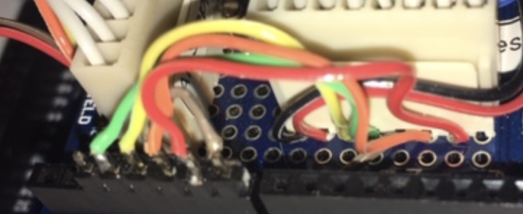Figure 13: SSD1306 Arduino Wiring
SSD 1306 Pin |  | Color | Arduino Pin | Pi Pin | Pi Role
1 | Gnd | Black |  | 9 | Gnd
2 | Vdd | Red |  | 1 | 3.3V
3 | SCK D0 | Yellow | PD-3 | 23 | SPI_CLK
4 | SDA D1 | Green | PD-4 | 19 | MOSI
5 | RES | Brown | PD-5 | 18 | GPIO 24
6 | DC | Orange | PD-6 | 16 | GPIO 23
7 | CS | Red | PD-7 | 24 | SPI_CE0
8

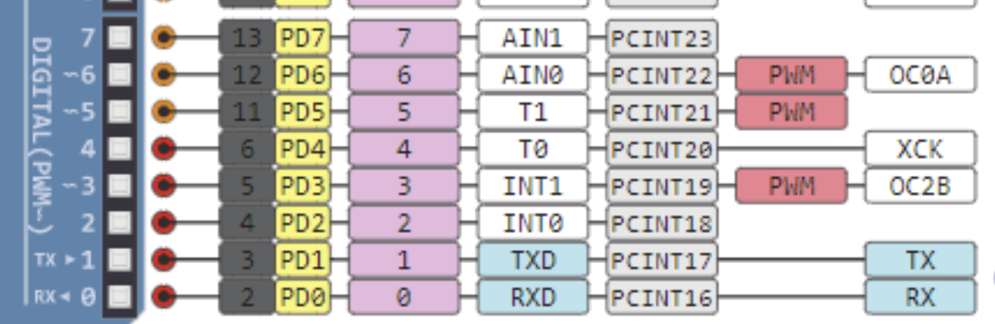
MISO (Master In Slave Out) - A line for sending data to the Master device
- MOSI (Master Out Slave In) - The Master line for sending data to peripheral devices
- SCK (Serial Clock) - A clock signal generated by the Master device to synchronise data transmission.

System Build

All target systems should have git, LibreOffice and python3 installed. If Arduino code is to be developed, the Mac and Window’s environments support installation of the Arduino IE. The Windows environments needs the C# development environment, which typically is Visual Studio Community Edition.

Windows Build (as of 20190504)
Chrome
Free Download Manager 5 (Chrome extension enabled)
GitHub Desktop (1.6.5)
Python 3 (3.7.3)
LibreOffice (6.2.3.2)
Visual Studio 12
Acronis True Image 2017

Lockheed Martin p3d v2
DCS World 2.5.4
X-Plane 11 Demo

It appeared post Visual Studio installation, p3D v2 errored with missing mfc100.dll. After trying a range of things finally resolved with Microsoft Visual C++ 2015-2019 Redistributable (x86) – 14.20.27508.

Resized Primary Screen size to bit Soniq Monitor (1804 * 1004)
Adjust Power Savings to Never Turon off and PC, and Sleep the screen after 25 minutes.
Linked PC to MS Account
Disabled One Drive (removed in Optional Windows Components – which had done a nasty and moved desk to a OneDrive directory – which of course was deleted
Changed UAC never to notify to stop alters when launching p3D and DCS.

Code To Dos

pyHWLink_USB_Reader

- Add Network stack for both sending state, as well as listening for Send_Query
- Add error handler
- Add Standardised logging
- for UDP_Input add code to respond to send all input state (ie respond to a CQ)

Index of Tables
DCS LUA Initialisation - Code Export.lua 21
DCA LUA Event Code - Export.lua 22
Packet Receive Loop 34

Index of Tables
X-Plane - Selecting Indexes to export 5
X-Plane GPS Indexes selected 6
X-Plane Joystick showing commands 7
X-Plane Keyboard showing commands 7
System Flows 13
Detailed System Flows 14
PhyHWLink_GUI_Sender GUI 17
PhyHWLink_Pri_Node_Input User Interface 20
Fields Selected for GPS Output 23
X-Plane GPS Data on the wire 23
SimConnect_To_IP GUI 24
SimConnect_To_IP Data on the wire 25

The SOIC port points to another Shim which maintains a TCP connection to the SOIC processes, converting the UDP payload into a TCP stream. Currently error handling does not address a restart of SOIC processes.
https://linuxconfig.org/how-to-change-from-default-to-alternative-python-version-on-debian-linux

